j. Weeding Collection

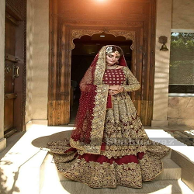

**COLOURS:**  mehron , green

**EFFECTIVE PRICE:**

RS : 80000

TYPE:

Bridal Collection

**AVAILABILITY:**

In Stock

**TIME DURATION:**

All Unstitched orders will be dispatched in 7 to 10 working days

**INSTRUCTIONS:**

* Actual Color may slightly vary from the image shown.  
  Unstitched Includes fabric only  
  Extra laces and tassles used in our outfits are only for shoot purposes and will not be included in outfit when purchased.
* Embroidered net with handmade embellishments for front yoke.
* Embroidered net for back yoke.